Ricoh named a worldwide leader in high speed inkjet in new IDC MarketScape report

Analysts cite: “Ricoh shows strength in all the key factors identified by the IDC MarketScape to ensure success in the high speed inkjet market.”

TOKYO, 06 February 2020 – Ricoh today announced that a new IDC MarketScape report names the company a worldwide leader in high speed inkjet, citing Ricoh’s broad strengths, including technological innovation, attentiveness to client feedback and a large installed base. The report, “IDC MarketScape: Worldwide High-Speed Inkjet Press 2019-2020 Vendor Assessment”¹ in particular noted Ricoh’s “business development programs with high visibility and strong reputation” as powerful complements to a robust technology portfolio.
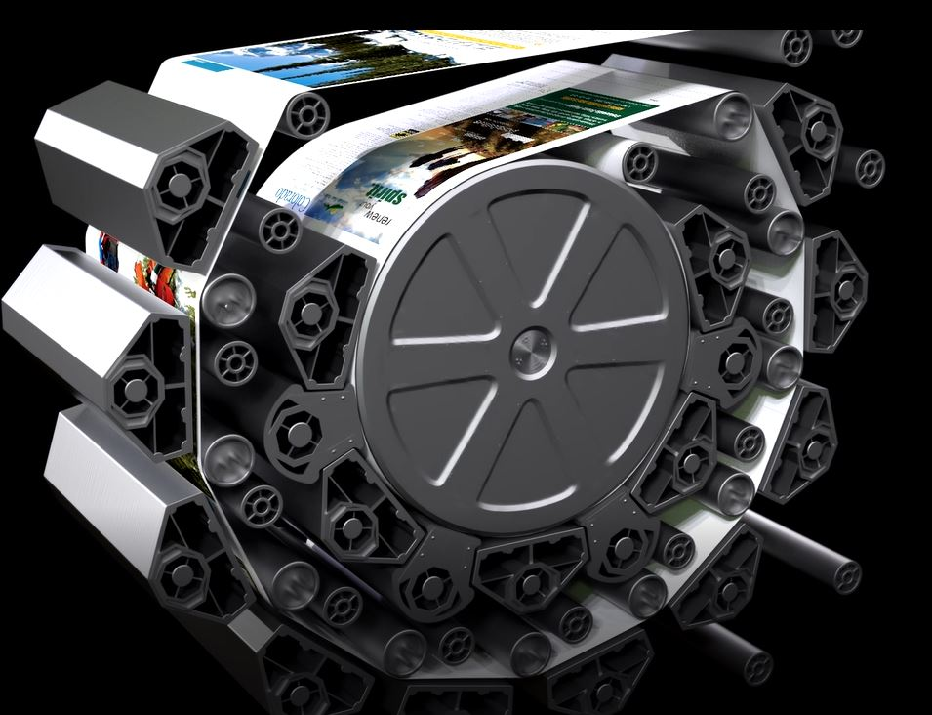

The Ricoh Pro™ VC70000’s dryer technology was among the advancements singled out by IDC.
Ricoh’s commitment to its clients’ success helped earn its global leader position. Analysts cited Ricoh’s continual technological advancements and heavy investments in ensuring client feedback is a part of its R&D process as a major positive. Most recently, this approach has driven game-changing successes such as the award winning RICOH Pro VC70000, which introduced Ricoh patented drying technology and Extended Gamut Inks. These innovations work together to increase ink limits for higher image quality, drive down turnaround times to help meet SLAs and increase throughput, and empower printing on uncoated, offset coated, inkjet treated and inkjet coated stocks without pre-treatment or priming, offering greater creative flexibility and lower paper costs. Continuing to invest more than $1 billion dollars annually in R&D, these innovations in response to real world pain points and client goals are the norm at Ricoh.

“Expanding beyond its transactional and direct mail roots, Ricoh’s introduction of the Ricoh Pro VC70000 dovetails perfectly with its expanding software and services to empower the company to more actively target the commercial print and graphics space,” said Amy Machado, Research Manager for IDC's Imaging, Printing, and Document Solutions, IDC. “Beyond its own growth in more diverse segments, Ricoh is looking to help its customers expand their offerings, as well.”

Ricoh builds long term alliances, with a consultative, tailored approach to implementation that does not end with a sale. Its representatives pursue a high touch strategy, so as business needs evolve, Ricoh’s ways of addressing them evolve, too. The IDC MarketScape cited Ricoh’s plans to continue growing its business services to help its clients continue to grow revenues and page volumes long after implementation as another key contributing factor to Ricoh’s strong market position.

Ricoh’s clients benefit from the deep expertise of its dedicated production service team of technicians, engineers and managers. Ricoh’s team supports clients with consulting and training services, as well as SaaS offerings. Consultation and training ranges from the technical - colour management, for instance - to the back office, sales plan development, operational excellence, and so on. This enables clients to improve their business on multiple fronts.

“Collaboratively working with clients to understand their needs, how they can adapt to market demands and developing the solutions and services to support them, is the foundation of everything we do at Ricoh,” said Eef de Ridder, Vice President, Commercial and Industrial Printing Group, Ricoh Europe. “The ability to work together openly and fully investigate all options from every angle enables us to develop technology that, not only performs, but elevates quality, productivity and creativity. The results speak for themselves in the longstanding relationships we have formed that go far beyond the sale and installation. While we help clients flourish they help us create solutions that will shape both our futures.”
For details on Ricoh's full line of production print products, services and solutions, please visit www.ricoh-europe.com.

¹ “IDC MarketScape: Worldwide High-Speed Inkjet Press 2019-2020 Vendor Assessment”, doc #US45705519, December 2019, https://www.idc.com/getdoc.jsp?containerId=US45705519
About IDC MarketScape
About IDC MarketScape: IDC MarketScape vendor assessment model is designed to provide an overview of the competitive fitness of ICT (information and communications technology) suppliers in a given market. The research methodology utilizes a rigorous scoring methodology based on both qualitative and quantitative criteria that results in a single graphical illustration of each vendor’s position within a given market. IDC MarketScape provides a clear framework in which the product and service offerings, capabilities and strategies, and current and future market success factors of IT and telecommunications vendors can be meaningfully compared. The framework also provides technology buyers with a 360-degree assessment of the strengths and weaknesses of current and prospective vendors.

| About Ricoh |
Ricoh is empowering digital workplaces using innovative technologies and services enabling individuals to work smarter. For more than 80 years, Ricoh has been driving innovation and is a leading provider of document management solutions, IT services, communication services, commercial and industrial printing, digital cameras, and industrial systems.
Headquartered in Tokyo, Ricoh Group operates in approximately 200 countries and regions. In the financial year ended March 2019, Ricoh Group had worldwide sales of 2,013 billion yen (approx. 18.1 billion USD).
For further information, please visit www.ricoh-europe.com
###

© 2020 RICOH COMPANY, LTD. All rights reserved. All referenced product names are
the trademarks of their respective companies.

For further information, please visit www.ricoh-europe.com

For further information, please contact:
Ricoh Europe PLC
Jack Gibson
Tel: +44 (0) 203 033 3766
E-mail: media@ricoh-europe.com
Homepage: www.ricoh-europe.com
Join us on Facebook: www.facebook.com/ricoheurope
Follow us on Twitter: www.twitter.com/ricoheurope
Visit the Ricoh media centre at: www.ricoh-europe.com/press

